**Dinosaur Time Machine**

by Paolo Latona  
Presented by Darebin Arts, as part of Melbourne International Comedy Festival

Social Script



**Image credit**: Brig Bee

**Image description**: Two people wearing safari outfits pop out from behind fern leaves.

Table of Contents

Table of Contents 2

**Where** 3

**When** 3

**Access Services** 3

Audience Experience 4

Front Entrance 4

Accessible Entrance 5

Box Office 6

Ushers 6

Bar 7

Toilets 7

Performance Space 9

**Getting to Darebin Arts Centre** 9

Public Transport Information 9

By Tram 9

By Train 11

By Bus 11

Bike or foot 11

By Car 12

# **Where**

Darebin Arts Centre

401 Bell Street, Preston Victoria 3072

# **When**

14 – 15 April 2025, 11am

Monday 14 April, 11am – 11:50am

Tuesday 15 April, 11am – 11:50am

Duration: 50mins without an interval

# **Access Services**

For more information or to let us know about your access needs, email the ticketing team: [Ticketing@darebin.vic.gov.au](mailto:Ticketing@darebin.vic.gov.au)



The performance is wheelchair accessible.



Darebin Arts Centre has accessible toilets on site.



You can book your complimentary companion ticket online or over the phone when purchasing tickets to any show. Contact our box office team for more information.

## Audience Experience

**Entry to Space**

The audience will enter from the main doors of the foyer.

The performance space will be open 15 minutes prior to start time.

Audiences will move to their allocated seating as designated on their ticket.

The main theatre doors will close at the performance start time.

General Notes

An Acknowledgement of Country will play in the opening sequence of the show.

**The Venue**

Image: a map of Darebin Arts Centre and its surrounding area. [Map](https://www.google.com/maps/place/Darebin+Arts+Centre/@-37.7455556,144.9980556,15z/data=!4m6!3m5!1s0x6ad644f16491c5b7:0x6003275a87dc8278!8m2!3d-37.7455556!4d144.9980556!16s%2Fg%2F1vd7619t?entry=ttu)

Image: Darebin Arts Centre as seen from Bell St, Preston

## Front Entrance

At Darebin Arts Centre, the main entrance is up the steps from the Darebin Arts Centre carpark. There are three steps equipped with grab rails and tactile surface indicators at the top and bottom of each step.

This entrance has a set of glass automatic doors leading to an airlock, followed by another set of glass automatic doors that provide entry to the venue. These doors are opened by Darebin Arts Centre staff 45 minutes before the performance start time. The main entrance glass doors to the street will be closed when the performance begins but can always be opened by staff if you need to leave during a performance.

## Accessible Entrance

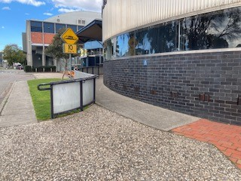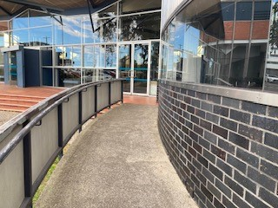

An accessible ramp is located to the right of the ront entrance. The ramp exits to the front entrance glass doors.

## Box Office

Once inside, the reception and box office are several metres in front and to the right of you. Here, our welcoming front of house staff will be available to provide any assistance you need.

## Ushers

Ushers will be wearing black uniforms with a Darebin City Council logo on the left shoulder of their shirt and a blue staff lanyard around their neck.

## Bar

Drinks and snacks can be purchased at the bar and taken into the theatre.

There is a lower section of the bar which is wheelchair accessible.

The bar accepts card only, not cash.

## Toilets

You can find directional signs for the toilets near the main entrance in the foyer

There are designated male and female toilets down the hall to the right of the Box Office.

All bathrooms have hand dryers with sensory activation.

There is a single use Accessible Toilet to the left of the Box Office and down the hall. You can access entry into the Accessible Toilet by pressing the large black button to the left of the door.

## Sensory Space

A Sensory Space is available for those who need a break from the stimulation of the performance. Soft chairs, a table and colouring sheets will be provided. The Sensory Space is down the hall from the Accessible Toilets.

## Performance Space

When the performers are ready, the ushers will announce that the ‘house is open’. They will open the doors to the Theatre, and you may enter at your own pace.

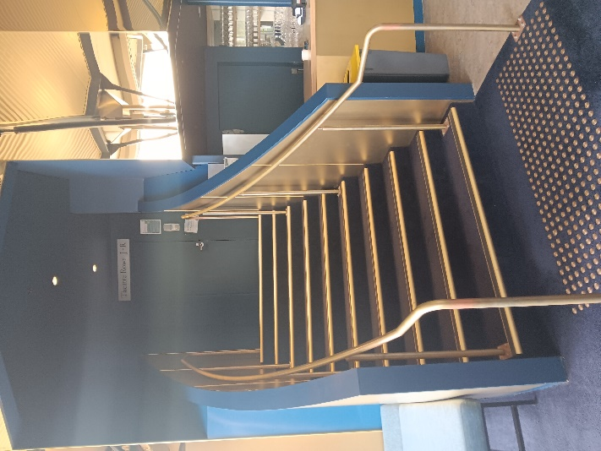 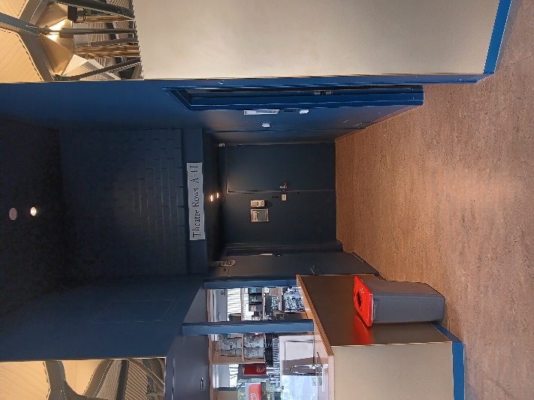

There are two entrances into the Theatre: on the left side of the bar and up the stairs is back entrance to the Theatre; on the right side is the front entrance. The front entrance has no stairs on either side of the entrance.

There is general seating for this event. An Usher can help you find a seat if you would like some help. An Usher will also be able to assist those who require wheelchair access.

# **Getting to Darebin Arts Centre**

## Public Transport Information

Darebin Arts Centre is easily accessible by tram, train, bus and bike. Help reduce your environmental impact and rethink your need to drive.

For help planning your tram, train or bus trip use the [PTV journey planner](https://www.ptv.vic.gov.au/journey).

## By Tram

Route 11 (get off at stop 34, and it’s a 10-minute walk)

Route 86 (get off at stop 45, and it’s a 10-minute walk)

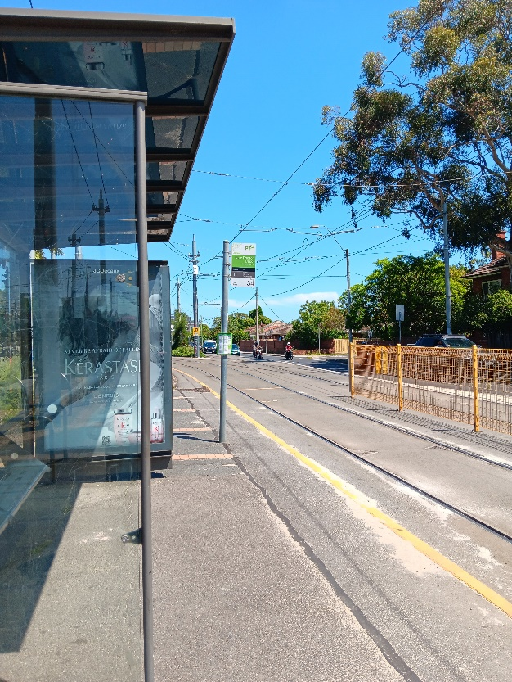 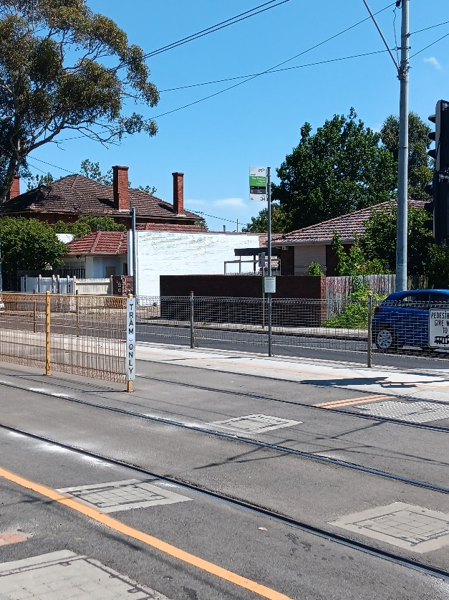

Image Descriptions: The Miller Street & St Georges Tram Stop #40 (From City). A waiting area for tram passengers and a green and white tram sign.

## By Train

Mernda Line (get off at Bell Station, and it’s a 5-minute walk)

[Bell Station Information](StopPage:::datetime=2024-01-15T23%3A19%3A27.185Z&directionId=-1&showAllDay=false&_auth=0a0d5b8206e39bb846bb74ee9bc75003eabb784d)

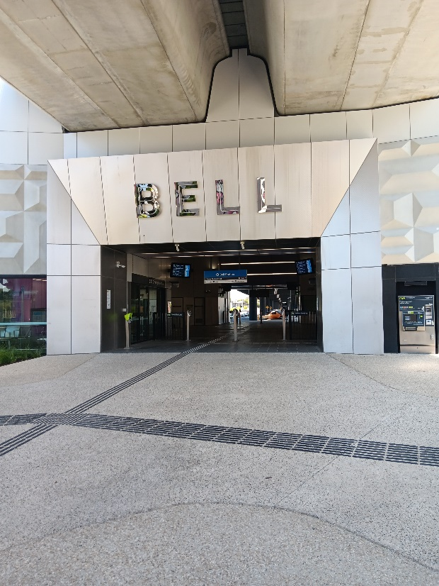

**Image Description**: The Bell Street Train Station entrance.

## By Bus

Route 513 (Get off at corner of Bell Street and St Georges Road, and it’s a 2-minute walk)

Route 903 (Get off at corner of Bell Street and St Georges Road, and it’s a 2-minute walk)

## Bike or foot

Darebin Arts Centre is conveniently located along the St Georges Road shared path, which is ideal for cycling or walking.

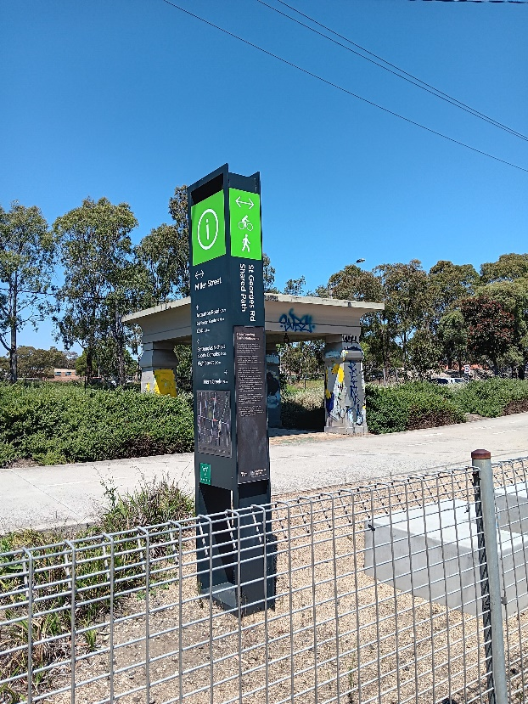

**Image Description**: A dark coloured pillar with a green Information sign at the top. A compact-gravel walking path behind it.

## By Car

Darebin Arts Centre's car park is accessible from Peter Street and St Georges Road. It has 136 unrestricted parking spaces, including 4 accessible spaces.

